Name:

SaiMadhav

Task6

I have taken a sample dataset and created a machine learning model so that by training the model with the dataset it generates a confusion matrix where we can predict the most activity done by the human from the provided dataset I have “convolutional neural networks” to train the model

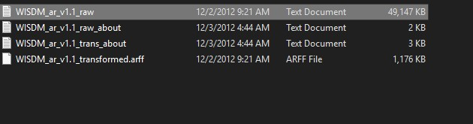

Sub folders in the dataset

Step 1: First, we load the dataset and then extract the data from the dataset and then we process the list from the dataset

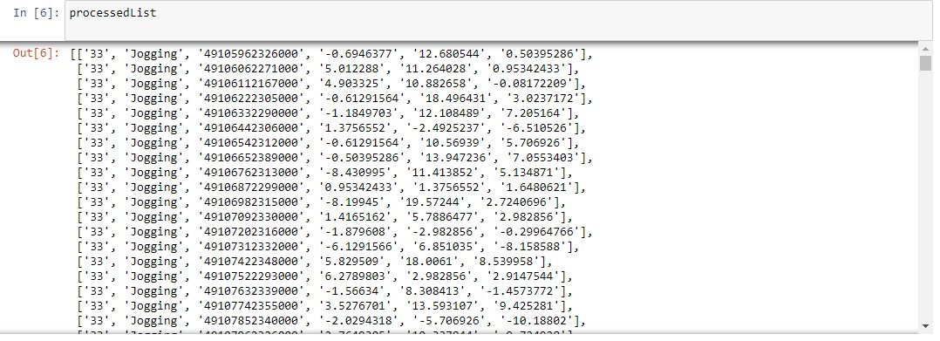

Step2:now we divide this data in to a tabular format so that we can process the graph. So we can plot the graph by dividing in to a x-axis ,y-axis and z-axis

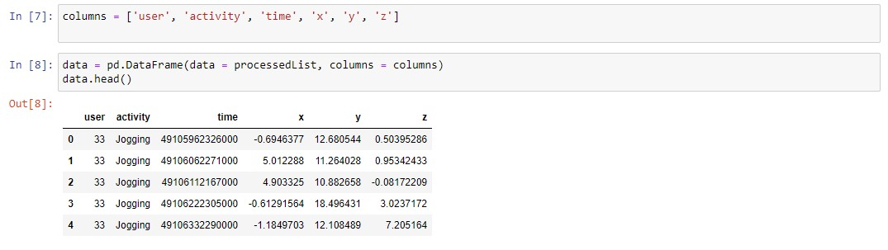

Step3: next we are going to shape the data as the data contains as the dataset contains 3,43,416 rows and 6 columns and we are gong to findout wether the dataset is having any null values or not and if any null values are present then we are going to remove that null values in th dataset

Step4:Now we categorize the activities of the human that are there in the dataset like walking,jogging,running,sleeping,climbing in to an x,y and z-axis and then a graph is plotten for the each of the following activity

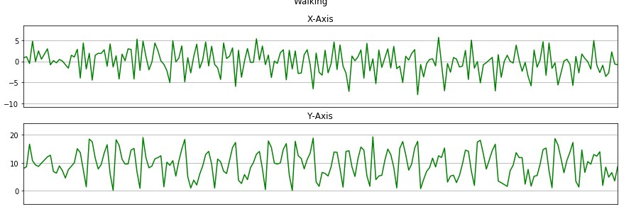

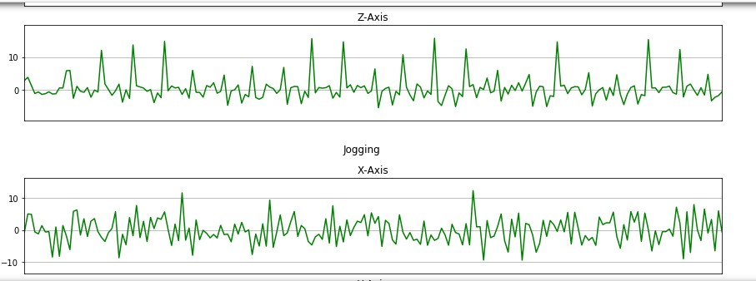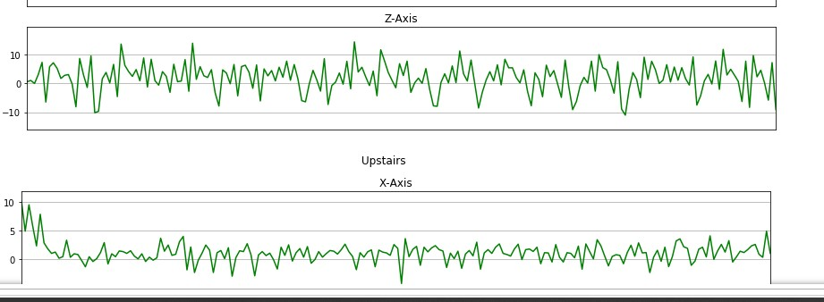

Like this for every acctivity in a dataset we are going to plot the graph and from this graph we going to again copy the values of the user to the table and we drop the previous values

Step5:Now we are going to balance the data from the values that we took from the above graph and got place in the table values and then we count how many values are recorded in the table and then again we count the how many people or person are doing the same activity like walking3555,sleeping-3667,upstairs-9876

Step6:In,this step we are going to preprocess the data from the dataset which we are currently having and then we are to going to build a convolutional neural network where the model is trained and tested and predicts the accuracy of the model

Step7:After predicting the accuracy of the trained model then we are going to save the model and further can be implemented to predicted the activity of the human

With 10 epochs, we achived 89% accuracy. It seems relatively average, until you realize that there are 6 different activities of a human in the dataset. Random guessing would give us 10% accuracy. We could have achieved even better accuracy values with more and real world video datasets of a human in dataset and more epochs during the training process but the systems (i.e., laptop) we are using to run this project can’t handle the load of that proportions. But as you can see, even with just 6 activites of a human with 3,43,416 values that is the activites performed by a human with 10 epochs, we achieved 89 % accuracy.

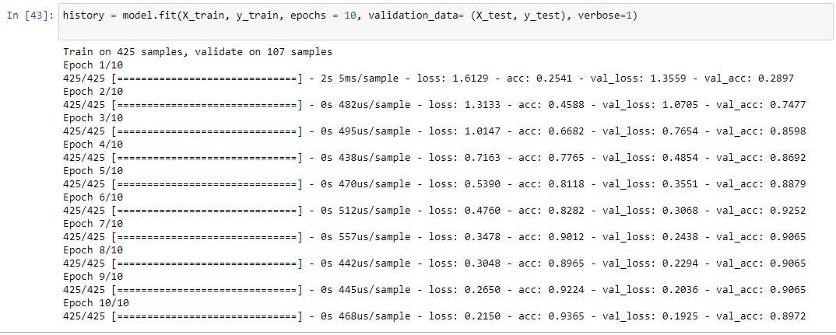

Fig.4.Training results

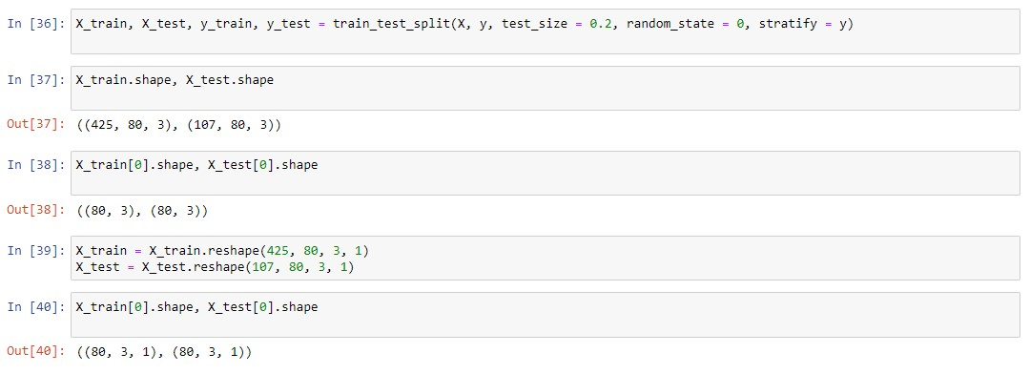

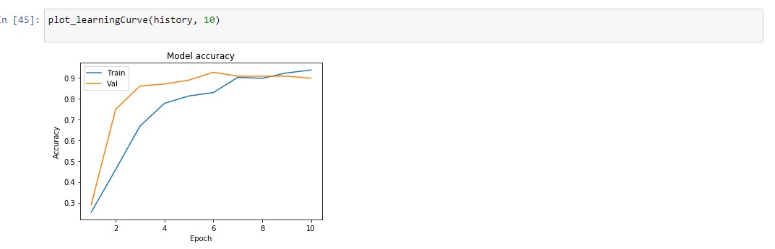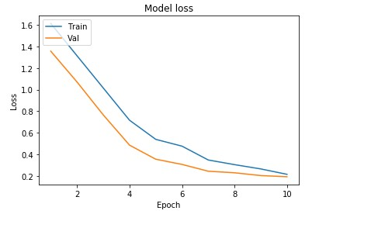

AND now from these trained data we are going to plot the confusion matrix from that confusion matrix we are going to see what is the major activity that is performed by human

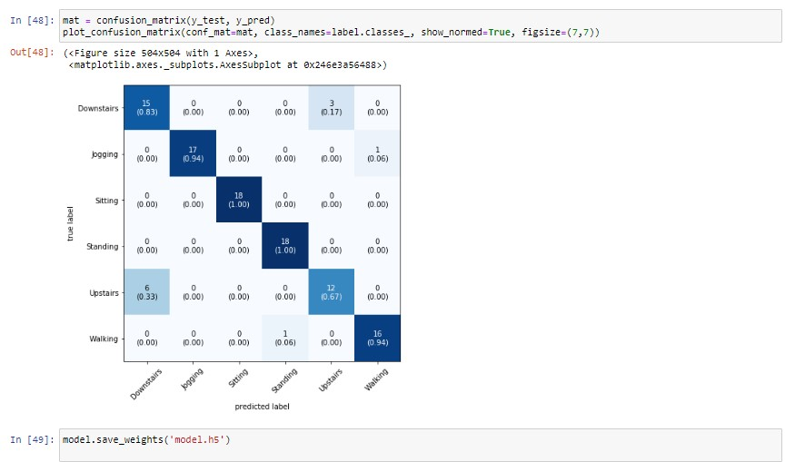Fig-7 prediction of the mostly done activity by the human through confusion matrix